Bosch Bar Code Scanner Setup and Documentation:

Last Updated: 06.05.2024

References and guides can be found at the bottom of this setup documentation.

Equipment:

* RJ45 – Xcode cable (x1)
* FS40 / FS20 (x1)
* Computer

This process uses TCP/IP and IPv4 as communication protocols.

Equipment setup:

**Step 1: Find your devices on your local network.**

* 1. Make sure your computer’s IP address is set to DHCP (automatic) under network settings.
  2. Open file explorer and navigate to “Network” in the navigation bar on the left.
  3. You should see your camera’s network connection appear:

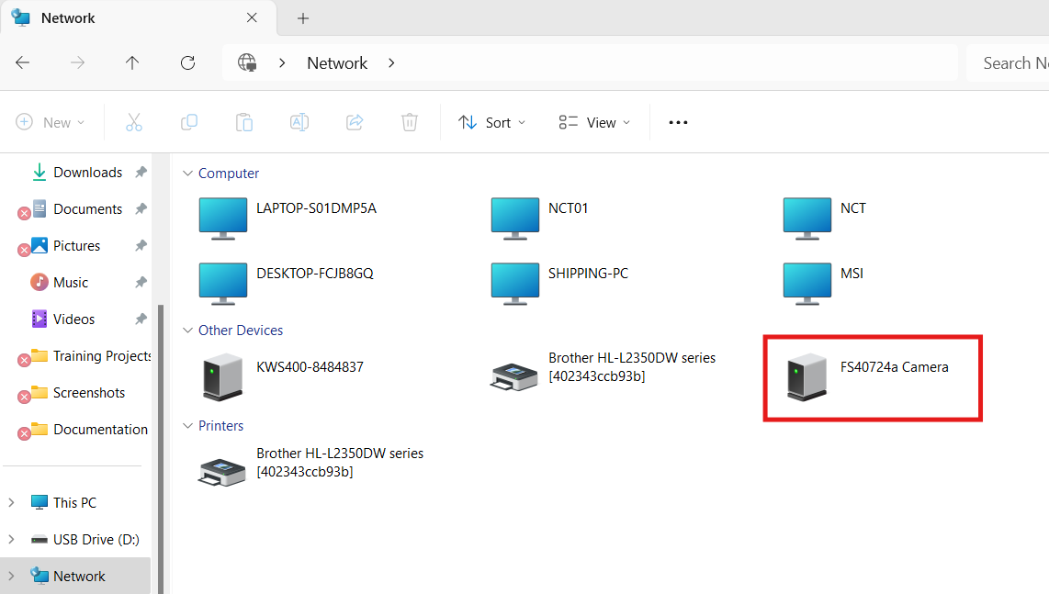

* 1. If a cameras connection appears then move to step 2.

If cameras are missing or no cameras appear some digging will need to be done.

* 1. Open command terminal and run “ipconfig /all” to find your ethernet’s IP address.

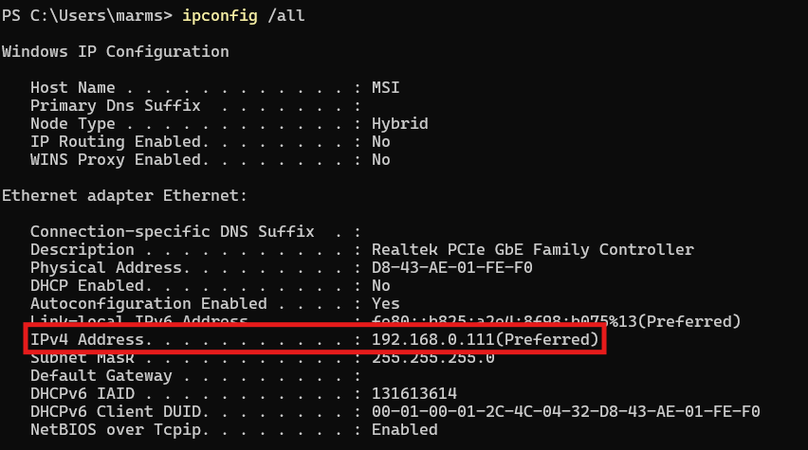

* 1. Change your computer’s IP assignment from DHCP to your ethernets IP address range.
  2. Open command terminal and run “ipconfig /all” to find your Devices IP address.
  3. If you see your device in the network folder. Proceed to step 2. Document the IP address if you need to come back.
  4. Repeat steps 1.1 – 1.4 to gather device information.
  5. If the camera still doesn’t appear. A factory reset may be needed to resolve the issue.  
     Click [Here](https://supportcommunity.zebra.com/s/article/000026280?language=en_US)

**Step 2: Camera Firmware Update**

By default the Zebra barcode scanners come with a lower firmware version than the Aurora Focus software uses. They need to be updated to the version of Aurora Focus that you have.

* 1. Open the Aurora Focus app to see what the current version is running on your computer.
  2. The versioning number is in the bottom right corner.  
     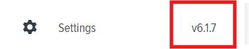
  3. 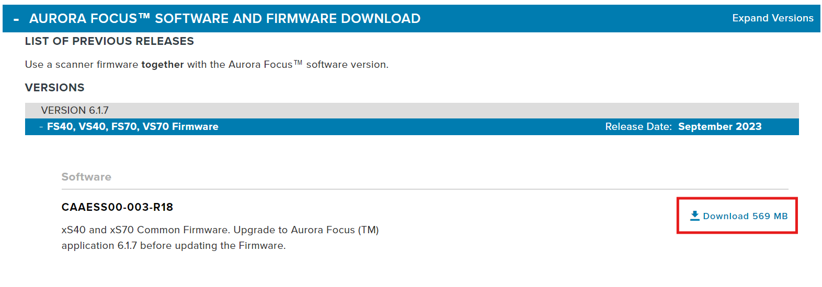Go to [Zebra’s website](https://www.zebra.com/us/en/support-downloads/industrial-machine-vision-and-fixed-scanners/zebra-aurora-previous-release.html) and download the firmware version necessary for your camera.
  4. Navigate to File Explorer and open the Network connections.
  5. Click on the camera that you want to update the firmware on.  
     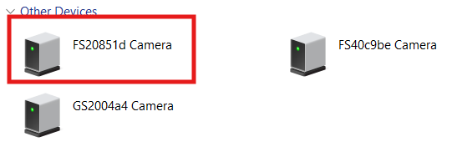
  6. In the URL remove any information that isn’t the devices IP.
  7. Navigate to the devices IP in the url.  
       
     
  8. Click on “Operator” in the top right corner and type the following:  
     Username: admin  
     Password: admin  
     
  9. Click on the gear icon next to “Admin”  
     
  10. Click “Firmware Update”, File Based Upload, then click choose file and pick the firmware that you downloaded for this camera.  
      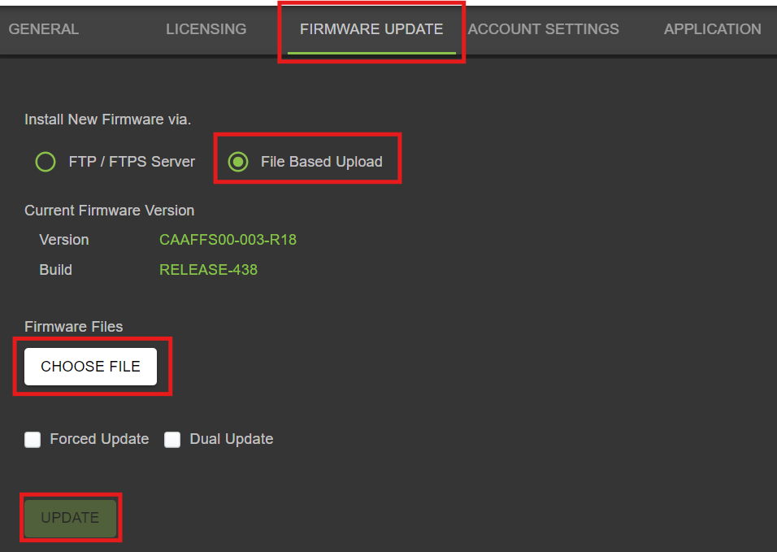
  11. Click “Update”.
  12. Repeat these steps for all your cameras before moving onto the next step.

**Step 3: Camera Configuration and IP Setup.**

* 1. Open “Aurora Focus” programming application.
  2. Open “View Devices” on the left side column.
  3. Find the camera you want to change IP’s on.
  4. Click “Manage” on the far right side of the row.
  5. Click “Communication” in the navigation bar to the left.
  6. Disable DHCP, change the IP address, change the subnet mask, and default gateway to specs.  
     IP Address: 192.168.0.xxx   
     Subnet : 255.255.255.0

Default Gateway: 192.168.0.1

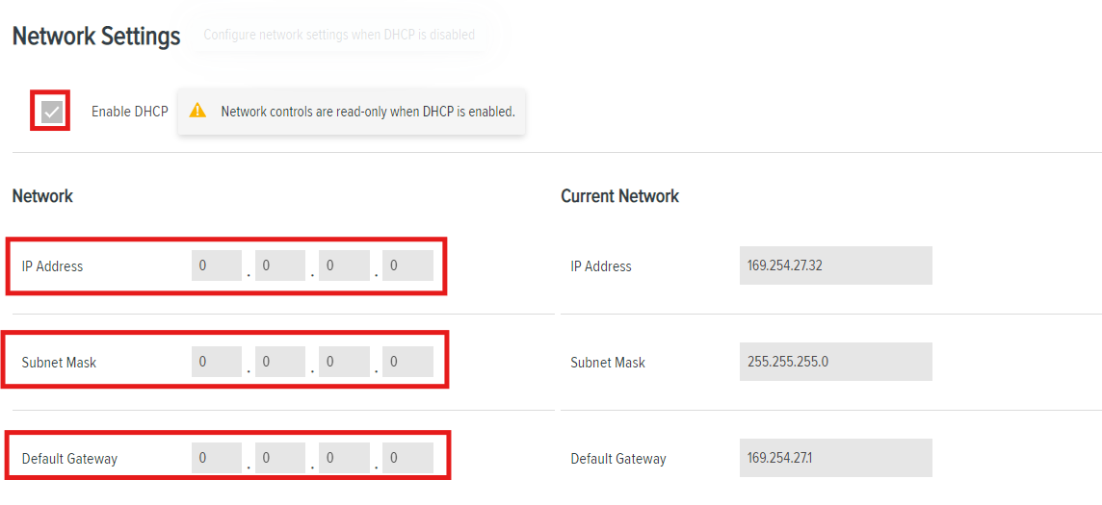

* 1. Click Apply in the top right corner.
  2. Repeat for remaining cameras.

At this point all of your devices should be on the same network. If a device doesn’t appear in the following steps. You will need to complete the appropriate steps for that device. Or factory reset the device and step back through the setup.

**Step 4: Setting up controls and results over TCP/IP**

* 1. Scroll down to “TCP / IP settings”.
  2. Under “Results” set the following parameters.  
     Enable TCP/IP Results : true  
     Connection Type : Client  
     IP Address : The IP Address you set the PC to, or the one you plan on using.  
     Results Port Number : 25251

Results Terminator : None  
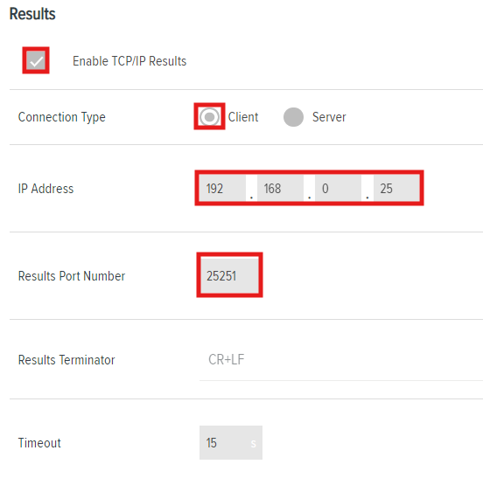

* 1. Click on “Open Job” in the top right corner. Select the program you want to run from the file.

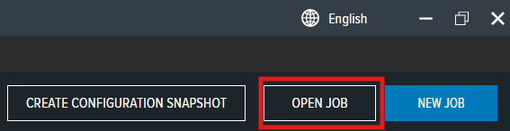

* 1. Open the Barcode Scanning Job. ‘[Bosch_13_Diget_Barcode_Scan](../Projects/Bosch/Bosch_2_Camera_System_2024/Bosch_13_Diget_Barcode_Scan.zjob)’
  2. Click “Capture”.
  3. Click “Acquisition Settings”
  4. Click “Barcode Auto Tune” with the camera in place to capture the barcode.  
     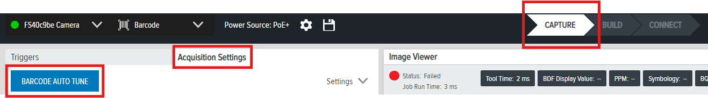
  5. Click “Deploy” in the top right corner. It should all turn green like the example bellow.

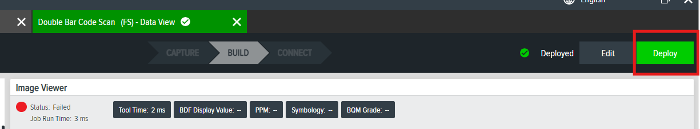

* 1. Close all the tabs you have open and return to the home tab. Don’t worry about saving your work, the camera already has the application saved and running now.
  2. The camera you just set up should change from “Managed” to “Connected” under status.

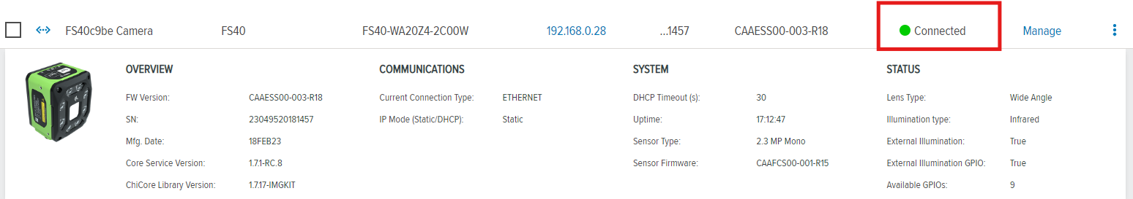

* 1. Repeat steps 2.1 – 2.18 for the remaining cameras you have.

**Step 5: Setting up the computer.**

5.1 Download and unzip “Bosch_Camera_System”

5.2 Open the unzipped folder and then the “dist” folder.

5.3 You will need to disable the firewall and malware tracker on the host PC.

The application does not have a digital signature attached so the computer assumes it is malicious content.

5.4 copy the “server.exe” application

5.5 type “windows key + r”

5.6 in the new window type “shell:startup” and press enter.

5.7 this will open the PC’s startup folder, paste the executable into the folder.

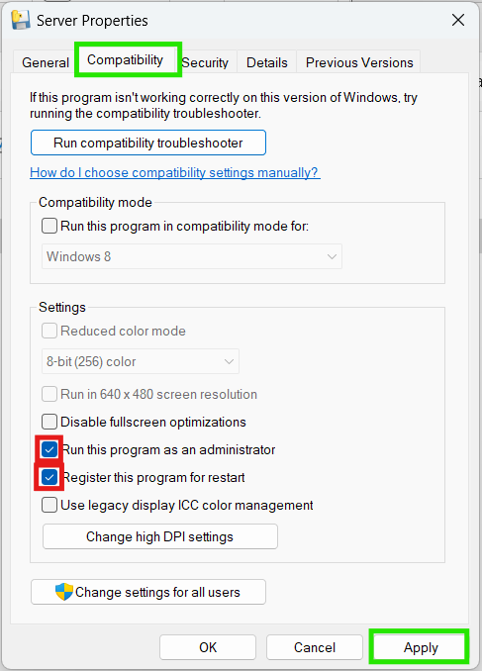5.8 Right click on the executable click “properties”. Then assign the following privileges: (click apply)

5.9 hit the window’s key a type “task scheduler”

5.10 Create a new task in the right corner.

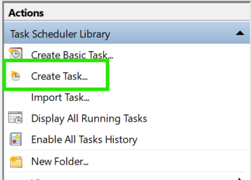

5.11 Set the following under “General”

Name: Bosch_QR_Barcode_Scan_Job

Location: <File Path to server.exe in starter folder.>

Run whether user is logged on or not: True

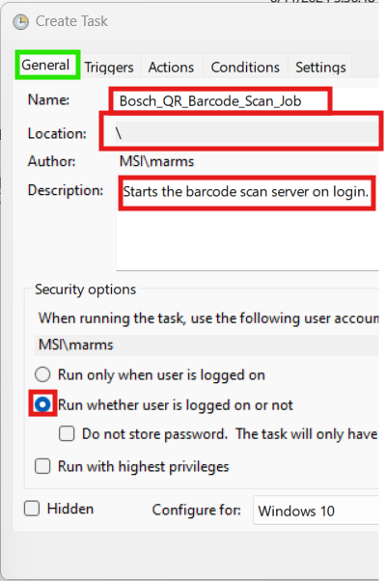

5.12 Click the “Triggers” tab and then “New…”

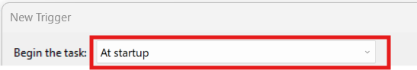

5.13 Click the “Actions” tab and then “New..”

Set the following:

Action: “Start a program”

Program/Script : Path to server.exe

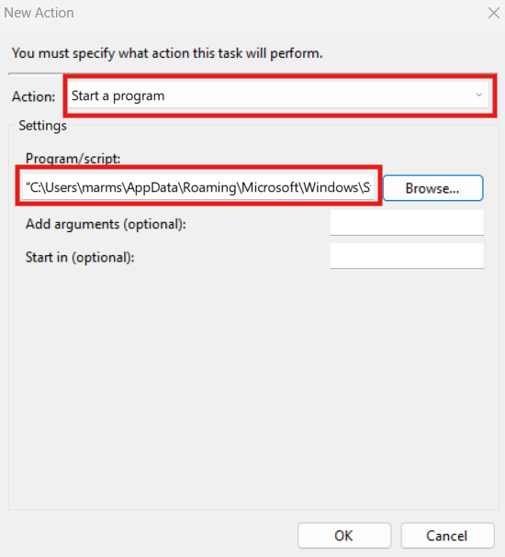

5.14Click on “Conditions” tab and set the following:  
Start the task only if the computer is on AC power: False

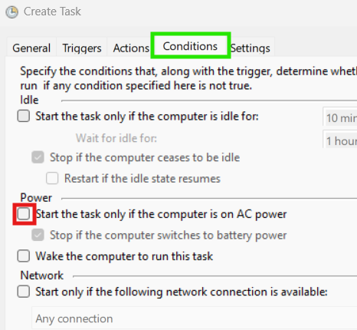

5.15 Click on “Settings” tab and make sure it appears as follows:  
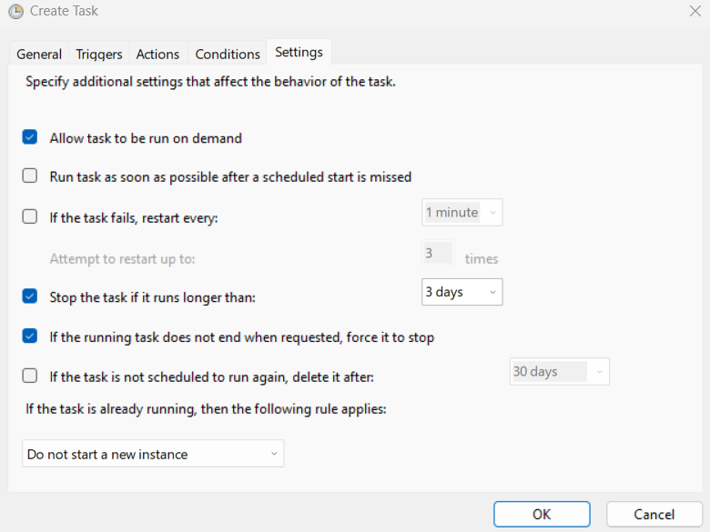

5.16 Click apply.

5.17 Copy the App.exe file in the “dist” from before, and place it on the desktop.

5.18 Restart your computer and begin testing.

**Testing and Troubleshooting:**

1. **Server setup:**

Open Task Scheduler and confirm the Bosch_QR_Barcode task is Running.



Open Task Manager and confirm that server.exe is running in the background.

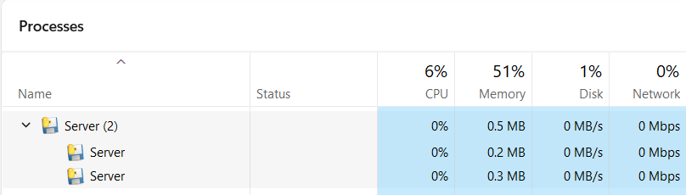

1. **App setup:**

Open the app.exe that you pasted on your desktop.

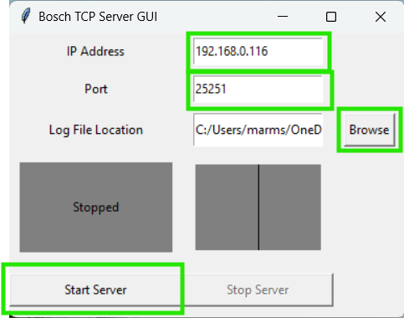  
Change the above settings and start the server.  
IP Address: Computer IP address

Port: Computer Port camera is sending data to.

Log File Location: Where the barcode scan job results will be saved on the computer (default: desktop)

Start Server: True

Click Start Server.

1. **Testing**

When you open the App it should be in a “Running” state. The server starts running by default.

Stop the server and change the settings to your requirements.

Scan a barcode then a matching QR code. The result should be a success.

Navigate to the location you are storing the xls file in.

Make sure the message reads “success”

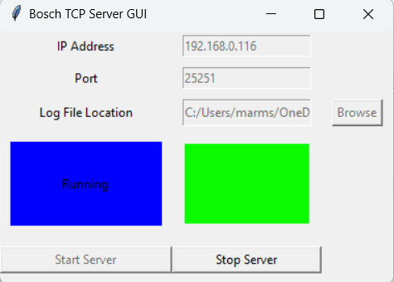

Scan a different QR code. The result should be a failure.

**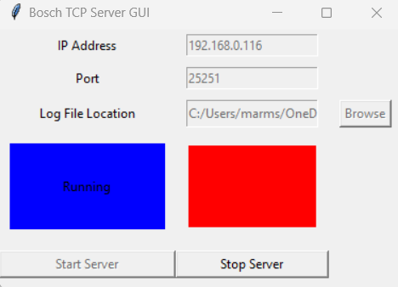  
If the excel file is open, the results will not update on the GUI until you close it.**

**If the config files are open the results will not update on the GUI.**

Double check that the excel file continues to update even if you are signed out of the computer by repeating the process above. There should be 2 more entries in the excel file once you log back in.

**Reference Material:**

Firmware Version (6.1.7) [5/03/2024]

* [Aurora Focus User Manual](https://www.zebra.com/content/dam/zebra_new_ia/en-us/manuals/barcode-scanners/fixed-mount/fs-vs/aurora-focus-ug-en.pdf)
* [FS40 Spec Sheet](https://www.peaktech.com/wp-content/uploads/fs40-specification-sheet-en-us.pdf)
* [Wiring Diagram](https://lucid.app/lucidchart/785a8de6-cc7e-40db-a720-60eb61c59051/edit?invitationId=inv_284bb4ed-0322-495d-b0ba-b1bfb7427305)